When Alexander the Great came to Jerusalem
“As I raised my eyes, look! there was a ram standing before the watercourse, and it had two horns. The two horns were tall, but one was higher than the other, and the higher one came up later.” (Daniel 8:3)
“As I kept watching, look! there was a male goat coming from the west crossing the surface of the whole earth without touching the ground. And the goat had a conspicuous horn between its eyes. It was coming toward the ram with the two horns, which I had seen standing before the watercourse; it was running toward it in a powerful rage. I saw it closing in on the ram, and it was filled with bitterness toward it. It struck down the ram and broke its two horns, and the ram was powerless to stand up to it. It threw the ram to the ground and trampled it down, and there was no one to rescue it from its power.” (Daniel 8: 5-7)
“The two-horned ram that you saw stands for the kings of Media and Persia. The hairy male goat stands for the king of Greece; and the great horn that was between its eyes stands for the first king.” (Daniel 8: 20, 21)
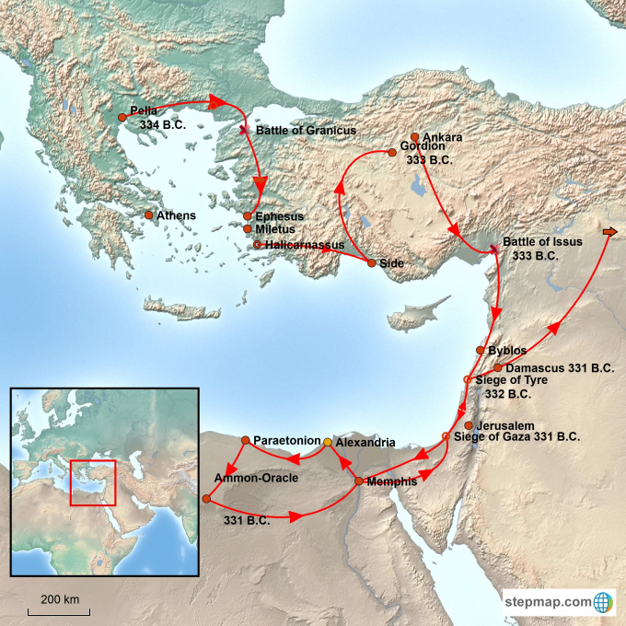
According to Flavius Josephus, after taking Tyre and Gaza, Alexander the Great visited Jerusalem. After a brief visit, Alexander’s forces continued south into Egypt. After conquering Egypt (and founding Alexandria) he turned his forces east through Damascus in 331 B.C and then pushed deep into the heart of the Persian empire (and beyond).

“…and Jaddus the high-priest, when he heard that, was in an agony, and under terror, as not knowing how he should meet the Macedonians, since the king was displeased at his foregoing disobedience. He therefore ordained that the people should make supplications, and should join with him in offering sacrifice to God, whom he besought to protect that nation, and to deliver them from the perils that were coming upon them; whereupon God warned him in a dream, which came upon him after he had offered sacrifice, that he should take courage, and adorn the city, and open the gates; that the rest should appear in white garments, but that he and the priests should meet the king in the habits proper to their order, without the dread of any ill consequences, which the providence of God would prevent…And when Jaddus understood that Alexander was not far from the city, he went out in procession, with the priests and the multitude of the citizens.”
“And when the Book of Daniel was showed him wherein Daniel declared that one of the Greeks should destroy the empire of the Persians, he supposed that himself was the person intended. And as he was then glad, he dismissed the multitude for the present.”
from https://biblereadingarcheology.com/2018/01/29/when-alexander-the-great-came-to-jerusalem/

