Lesson 4 Vocabulary

These are words that are frequently used in the context of this lesson:
- Nouns:
Descendant  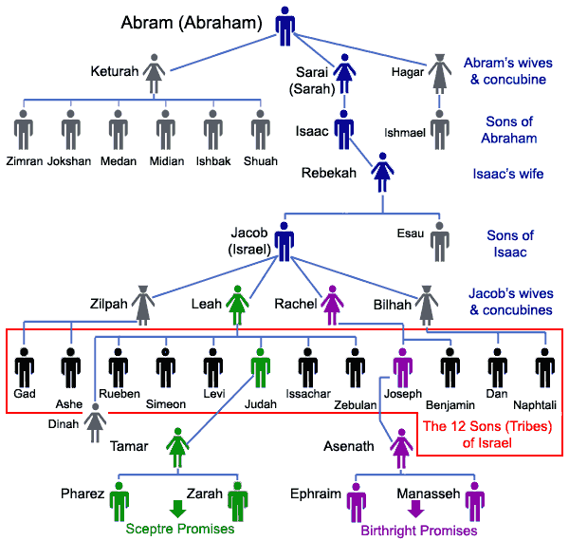 | A person, plant or animal that is descended from a particular ancestor.  French:  - je descends; I go down  - Je descendrai: I will go down  Latin for descend  - de = down +  - scandere = to climb: to climb down  Abraham had many descendants. In the chart you’ll see the direct descendants of Abraham.
Drought  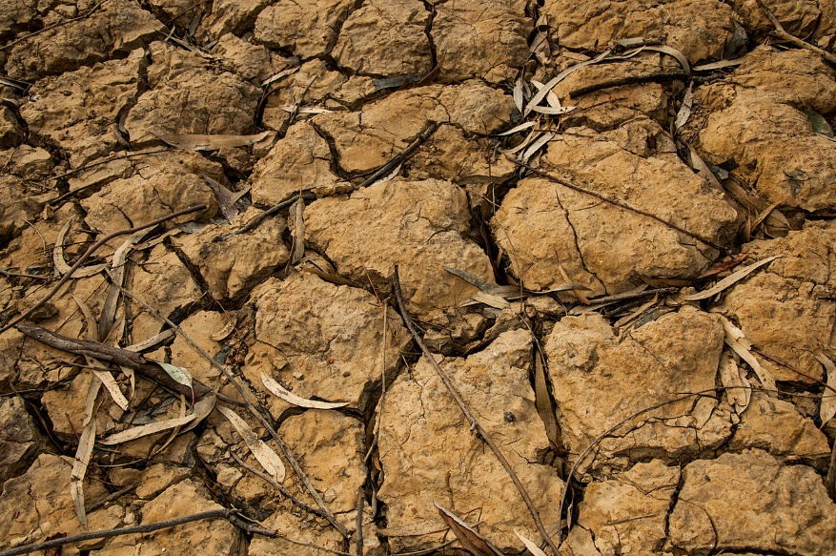  Picture by Jeroen Moes, Wiki Commons | A long period of abnormally low rainfall leading to a water shortage (note pronunciation).  Because of the drought Jacob sent his sons to buy grain in Egypt.

- Verbs
Dwell  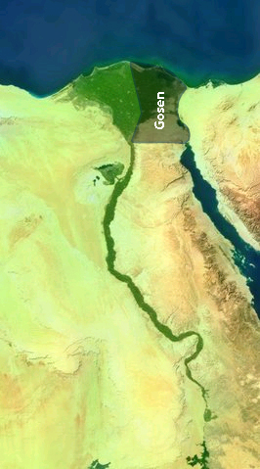  Nasa | live in or at a specified place  The Israelites dwelled in Goshen.  They dwelled in tents.
fulfil | - Achieve or get something that was desired/ promised/ predicted or prophesied (e.g.in the Bible)  - Carry out a duty or role as promised or expected  God always fulfils His promises.  He fulfils the promise made to Abraham to become a great nation.  He fulfils the promise made to Abraham to give him the land.

Prefix de-
A letter or group of letters placed at the beginning of a word to change its meaning. The
prefix de- = to reverse the action or take away.

Prefix de + verbs | Verbs beginning with de- the prefix changes the meaning to reverse the action/ take away.  In the word denounce we find the prefix de- placed before the word  announce = make a formal public statement about a fact.  de- = reverse the action  denounce = publicly declare to be wrong
defrost
detour

Prefix de + nouns
More words with de- Can you find other words that begin with the prefix de-:

